**Safety Nap Alarm User Guide:**

**By: Gundam Style**

**Subsystem 1 (Countdown timer) User Step Guide:**

* Power on device by inserting usb cable to port on Arduino.
* Once the LCD screen lights up, use potentiometer to adjust brightness then there will be a display “Enter Minutes:” at start up.
* To increment the timer press button 2.
  1. This will increment by 1 minute with each press
* To decrement the timer press button 3 (once the timer hits 0 we cannot decrement further).
  1. Decrement button, decrements by 1 minute on each press.
* To start the timer we press button 1 to initiate the countdown timer.
  1. To stop while the timer is counting down we can also press button 1 (only as the countdown timer is running.)
* Once the timer hits 0 then it will communicate with Arduino 2 which turns on the buzzer to wake up the user. (This will be done via I2C communication as represented in the setup diagram documentation).

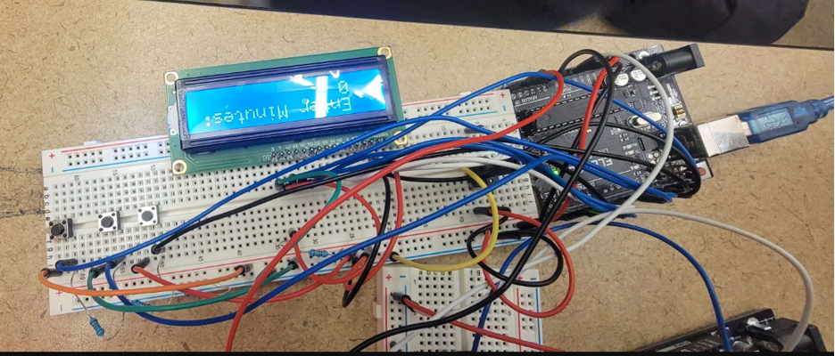

Buttons:

Potentiometer: 1 2 3

Adjust Screen Brightness

LCD Screen displays a timer countdown.

**Subsystem 2 (Fan Alarm) User Step Guide:**

* Power on device by inserting usb cable to port on Arduino
* The buzzer automatically starts buzzing when it receives a signal from subsystem 1 that the alarm has finished. (This will be done via I2C communication as represented in the setup diagram documentation).
* The fan motor automatically starts rotating when it receives a signal from subsystem 3 that the temperature is too hot. (This will be done via I2C communication as represented in the setup diagram documentation).
* The left push button will turn off the buzzer
* The right push button will turn off the fan

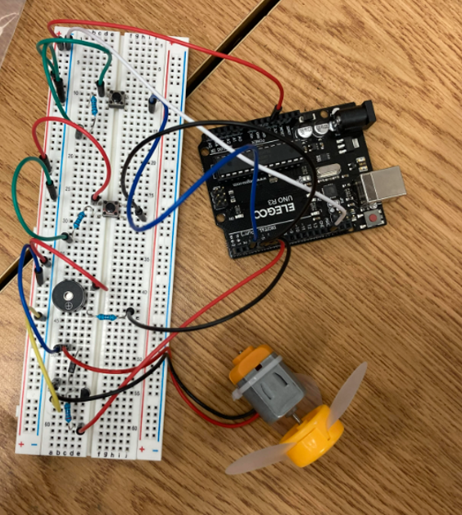

Fan

Button to turn

off buzzer Button to turn off fan

Buzzer

**Subsystem 3 (Temperature sensor and RGB led) User Step Guide:**

1. Power on device by inserting usb cable to port on Arduino.
2. This subsystem automatically senses temperature and based on that temperature the RGB LED will light up different colors. Red means hot, white means normal, blue means cold
3. If the RGB LED is red that means it's too hot and a signal will be sent to subsystem 2. (This will be done via I2C communication as represented in the setup diagram documentation).

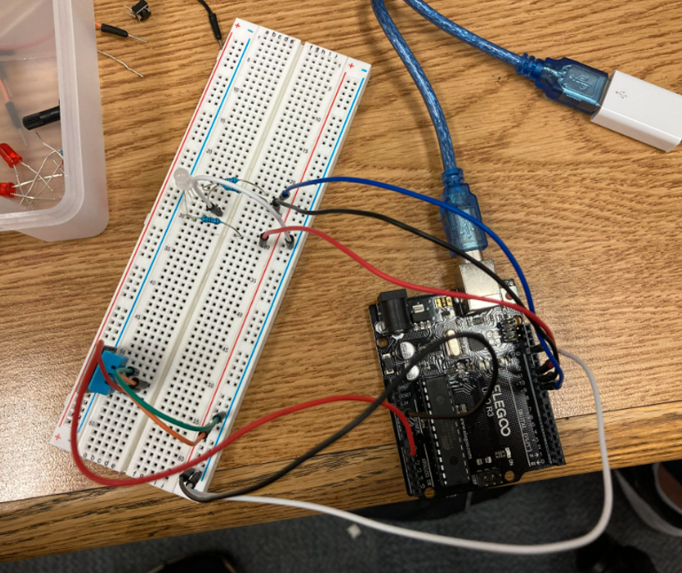

RGB LED

Temperature Sensor

**Full project:**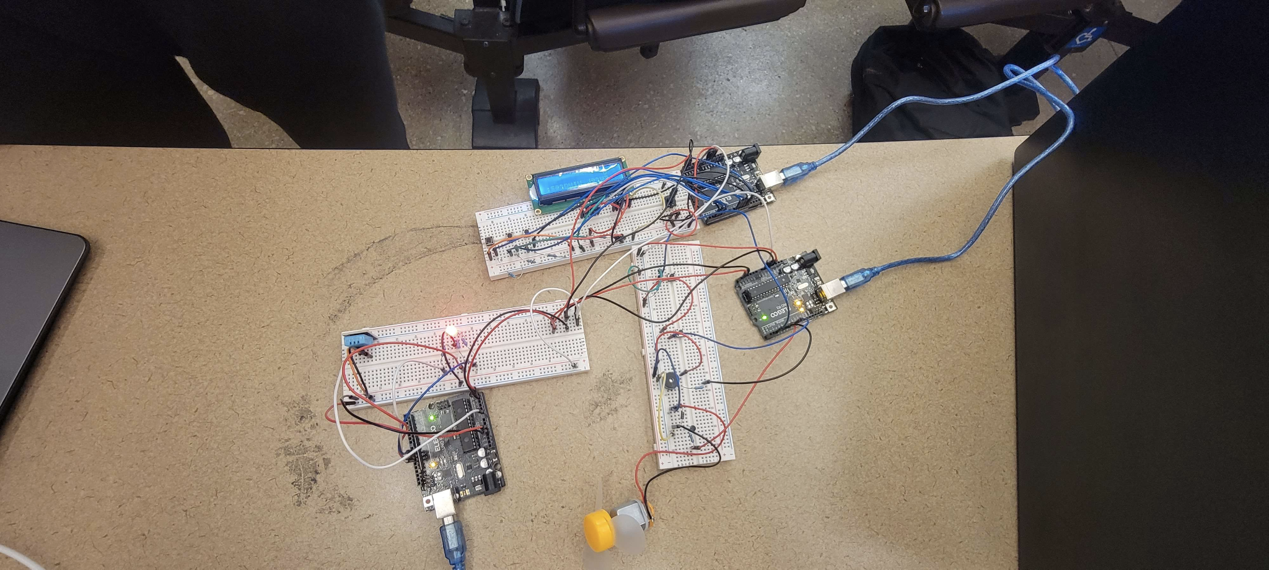

Subsystem 1:

⏱️Countdown timer ➡️

Subsystem 2: Fan Alarm🔕

I2C ⬆️communication

Subsystem 3:

Temperature Sensor🌡️